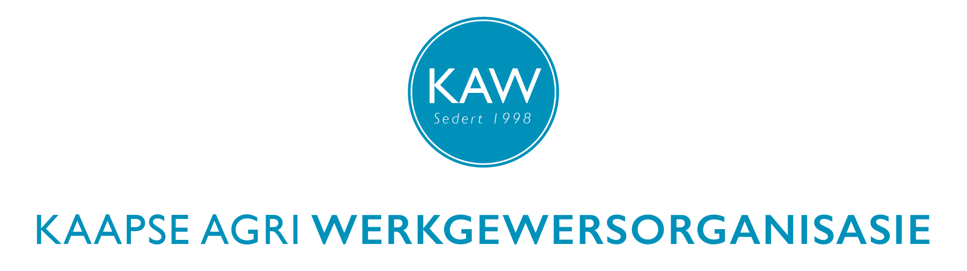

**HR KONFERENSIE: 26 JULIE 2016 // HR CONFERENCE: 26 JULY 2016**

*Olive Grove saal/Hall, Infrutec, Helshoogtepad/Road, Stellenbosch*

**REGISTRASIEVORM - REGISTRATION FORM**

Afgevaardigde se naam en van / Name and surname of representative:

1. .................................................................................................................
2. .................................................................................................................
3. .................................................................................................................
4. .................................................................................................................

Organisasie / Organisation: …………………..…...… Lidnr./ Memb. no: ...........

*Die registrasiefooi is* ***R250*** *per persoon. Om toegang te verseker moet registrasiefooie vóóraf betaal word, en betalingsbewyse en inskrywingsvorms per e-pos gestuur word aan* [*caeo2@maxitec.co.za*](mailto:caeo2@maxitec.co.za) *voor of op 18 Julie.*

*The registration fee is* ***R250*** *per person. To ensure admission registration fees need to be paid in advance and payment advices and registration forms sent by e-mail to* [*caeo2@maxitec.co.za*](mailto:caeo2@maxitec.co.za) *by the 18th of July.*

*Ons bankbesonderhede is: / Our banking details are:*

***Rek. Naam/ Acc. name:*****Kaapse Agri Werkgewersorganisasie**

***Bank:* Nedbank,**

***Tak/branch:* 198 765**

***Rek nommer/ Acc number:* 1470 0280 50**

